UI testing and API testing:
 | Test case | UI tesing | API testing | Bug | notes
UI_01 | Verify search ‘Nike react’ | Pass | Pass
UI_02 | Verify view cart for Nike react infinity run flyknkit | pass | pass
UI_03 | Verify “add to cart” for Nike react infinity run flyknit | pass | pass
UI_04 | Verify view cart for Nike odyssey react flyknit 2 | fail | fail | UI error for wrong color. Same for API due to incorrect payload | See screenshot below
UI_05 | Verify add to cart for Nike odyssey react flyknit 2 | fail | fail | Both UI and API shows color and size error | See screenshot below

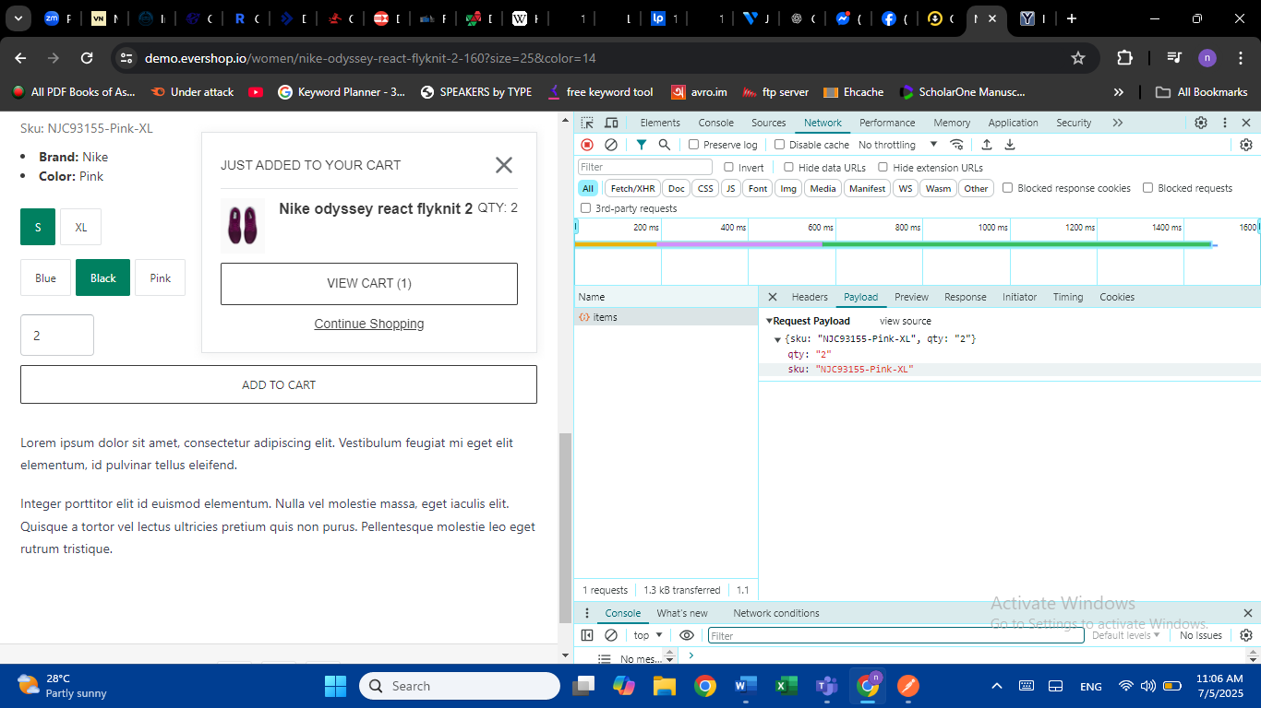
Image for UI_4
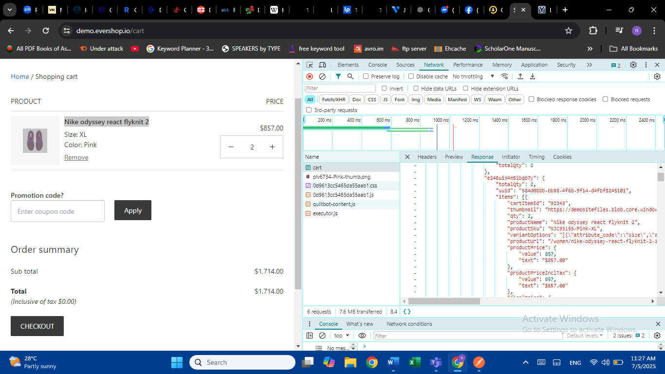
Image for UI_5

